

MySQL Assignment

Day 2 Tasks

Jonah Gray

GMCA 5

|  | | |
| --- | --- | --- |
|  |  |  |

**Task 1** - Find the number of cities in the USA, this is achieved by using the count statement and filtering the country code to only count those in the USA.

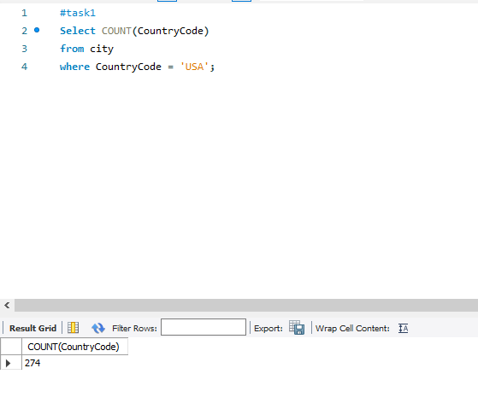

**Task 2 -** Find out the population and average life expectancy for people in Argentina. For this we use the AVG command to find the average and filter by the argentina country code.

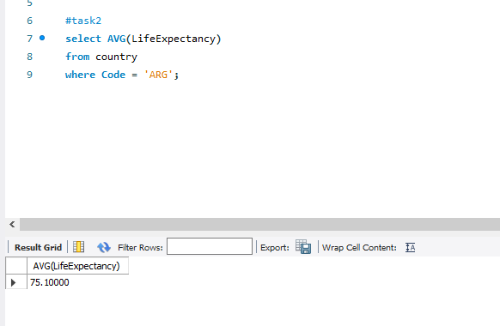

**Task 3** - Find the country with the highest life expectancy. This is done by ordering the life expectancy from high to low, and then using limit to return only the first record.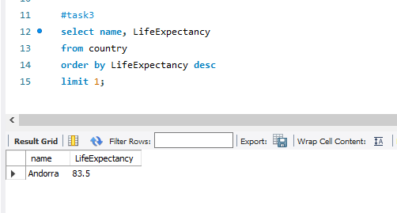

**Task 4** - Find 25 cities that start with the letter F. We achieve this by using the LIKE statement to find cities starting with the letter F then limiting the first 25 records that are returned.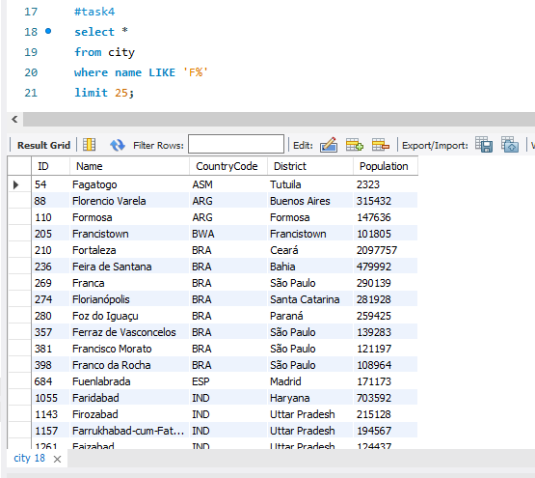

**Task 5** - Find the Id, Name and Population from the city table and return only the first 10 rows. This is done by using the limit statement to only return 10 rows.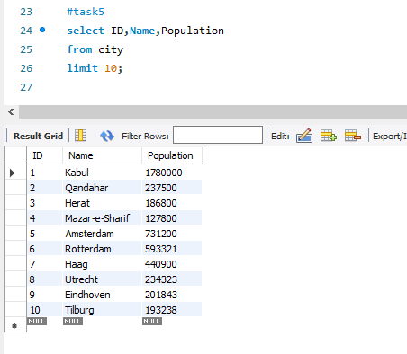

**Task 6** - Find the cities with a population larger than 2 million. This is done by using the where command to filter out values below 2million.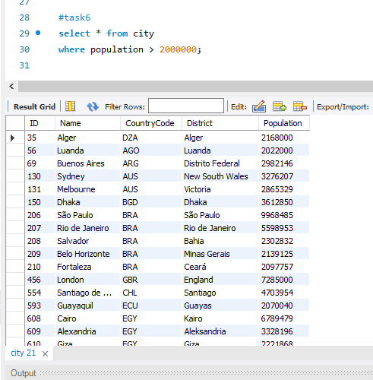

**Task 7** - Find all the cities beginning with ‘Be’. This is done by using the like statement and filtering only for cities beginning with be.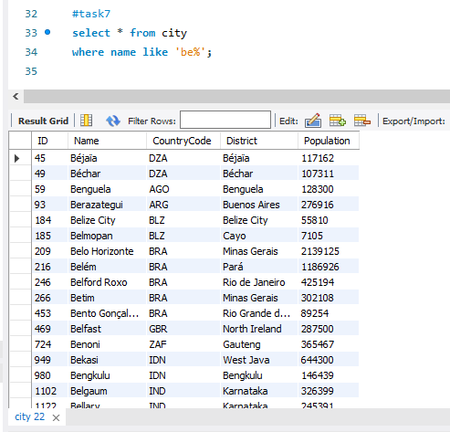

**Task 8** - Find cities with a population between 500000 and 1000000. This is done by using the Where and And statement to add two filters at once.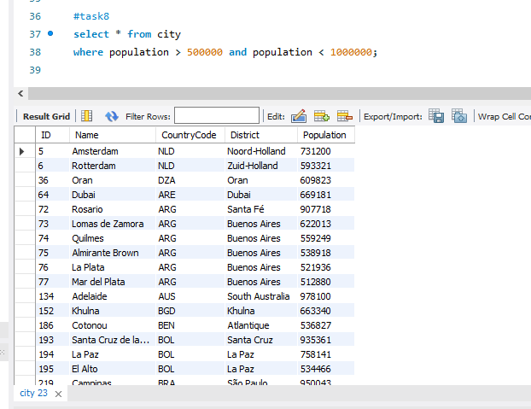

**Task 9** - Find the city with the lowest population. This is done by filtering the population from lowest to highest then limited the query to only return the first(lowest) value.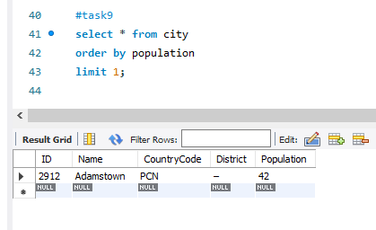

**Task 10** - EER Diagram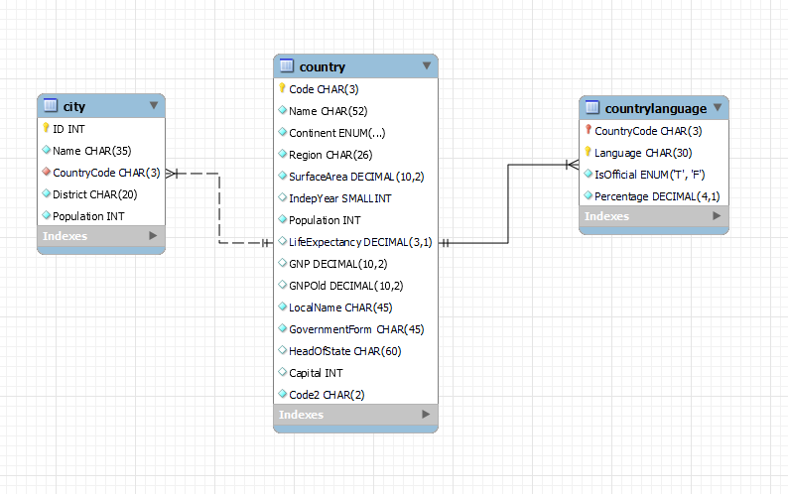

**Task 10** - Answers

* The Primary Key in the Country Table is ‘Code’
* The Primary Key in the City Table is ‘ID’
* The Primary Key in countrylanguage table is ‘CountryCode’
* The Foreign Key in the City Table is ‘CountryCode’
* The Foreign Key in the Countrylanguage Table is ‘ CountryCode’